The village that is falling into the sea

Introduction

"Happisburgh, a town just under 20 miles away from Norwich, is the most at-risk area of coastal erosion in the UK over the next 20 years"…………. "This could mean that houses and holiday lets close to the shoreline could fall into the sea". (Confused.com 2019).
National Geographic (Yong, E July 7, 2010 Norfolk, the home of the earliest known humans in Britain) was even more dramatic – "The entire lot might imminently fall into the sea, which would put it on the map just as it catastrophically disappears from it"
The estimated rate of erosion for Happisburgh is a further 97m in up to 20 years and up to 150m in up to 50 years. This is in addition to the dramatic loss of cliff face of over 200m in the last 20 years and represents a genuinely catastrophic scenario for the community when little is being done to protect its future. Severe storms like those experienced in 2013 will accelerate the erosion.

Properties have already been sacrificed to the sea and many others will go the same way unless a solution is found.

Happisburgh Cliffs are up to 10m high and comprise sands, silts and clay, making them very soft and susceptible to erosion. They were declared a Site of Special Scientific Interest (SSSI) in 1985 by English Nature (now Natural England) due to the discovery of "a stunning array of plants, mammals and insect makes in fossil beds…………among the most impressive from any Early Palaeolithic site in the world" (British Museum 2019 Fossils from Happisburgh).

The discoveries have continued and in 2013, following a great storm, " a team of scientists led by the British Museum, Natural History Museum and Queen Mary University of London discovered a series of footprints left by early humans in ancient estuary muds over 800,000 years ago" (British Museum May 2013 New discovery at Happisburgh The earliest human footprints outside Africa)

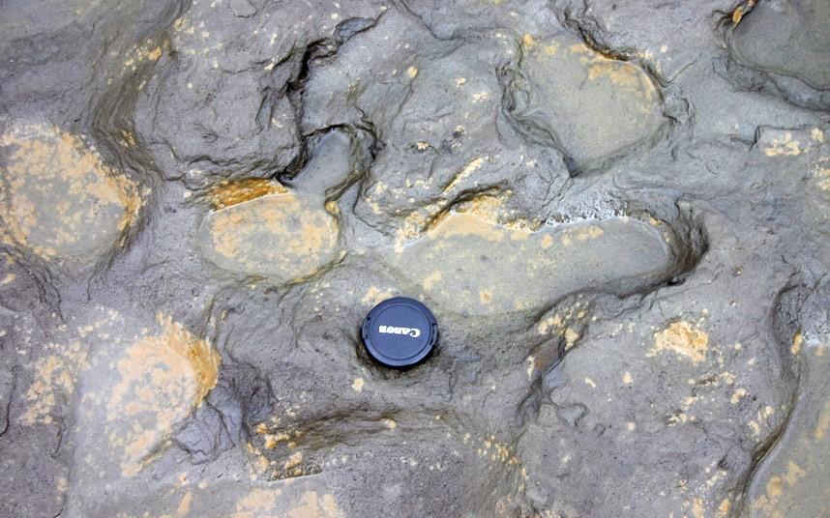
Fig 1 Eastern Daily News Ancient footprints
The SSSI requires that access to the cliffs is maintained for scientific research purposes, which also means that protecting the cliffs from further erosion is restricted.
In recent years, the loss of land and homes to erosion has accelerated with a whole holiday static caravan site being relocated within the last 12 months as the field drops into the North Sea. A number of houses were demolished as the cliff edged towards them and as many as further 20-30 houses are expected to disappear within the next 20 years. Longer term projections are even more dramatic as the cliff edge is expected to reach the St Mary's church within 50 years. It was once 1 mile from the sea.

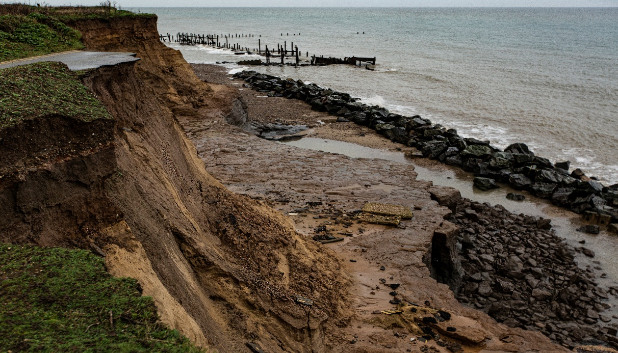
Fig 2 Alan D Horn Nov 2019

In 2010, the Government set up a "Pathfinder" fund to compensate people for losses due to coastal erosion and North Norfolk District Council was granted an allocation of £3.0m which, in 2011 was used amongst a number of initiatives to acquire properties for demolition and help the caravan site to relocate. Since this initiative, the Government calculation for "cost/benefit" has moved from 1:1 to 10:1 which means that (say) another £3m grant must show a £30m benefit. The is means that for future property losses there is no form of compensation available.

The next property to go – within 12 months
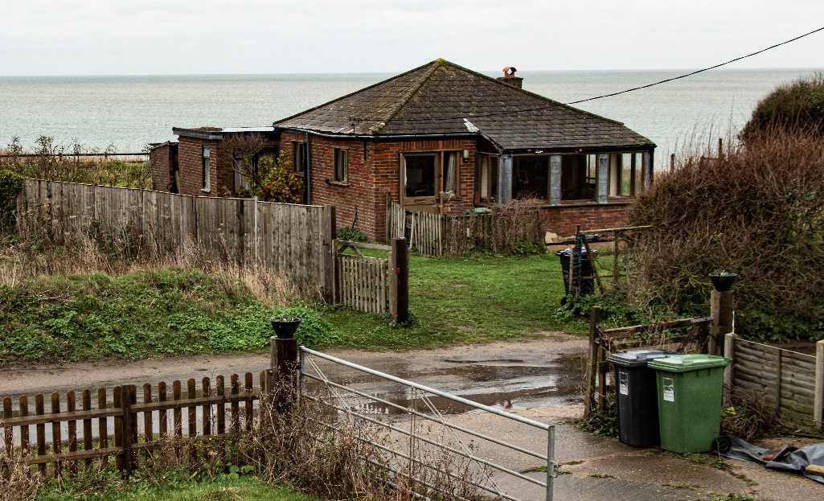
Fig 3 Alan D Horn Nov 2019

The issue of protection is further exacerbated locally by NNDC's budget for coastal protection which has been almost halved for 2019. The situation nationwide is confusing due to an apparent lack of agreement between two government departments (DEFRA and the Environment Agency) regarding their understanding of the seriousness of the threat of erosion and flooding. Further, the report from the Committee on Climate Change (CCC) stating that the issue far more serious than the published Government statistics, has had little impact and there is little evidence that government will intervene further.

What is frustrating for the Happisburgh community is that just a couple of miles up the coast there is a major project to "sandscape" the beach at Bacton to protect the gas terminal (and as a consequence, the housing). This is mainly funded by the owners of the terminal. The life expectancy of this scheme is 20 years whereas in Happisburgh the sea would have advanced by almost 100m by then.

Global warming and the projected increase in sea level will increase wave height, reducing the ability of the "Rock Armour" at Happisburgh to insignificant - at best, as even now its protection is limited.

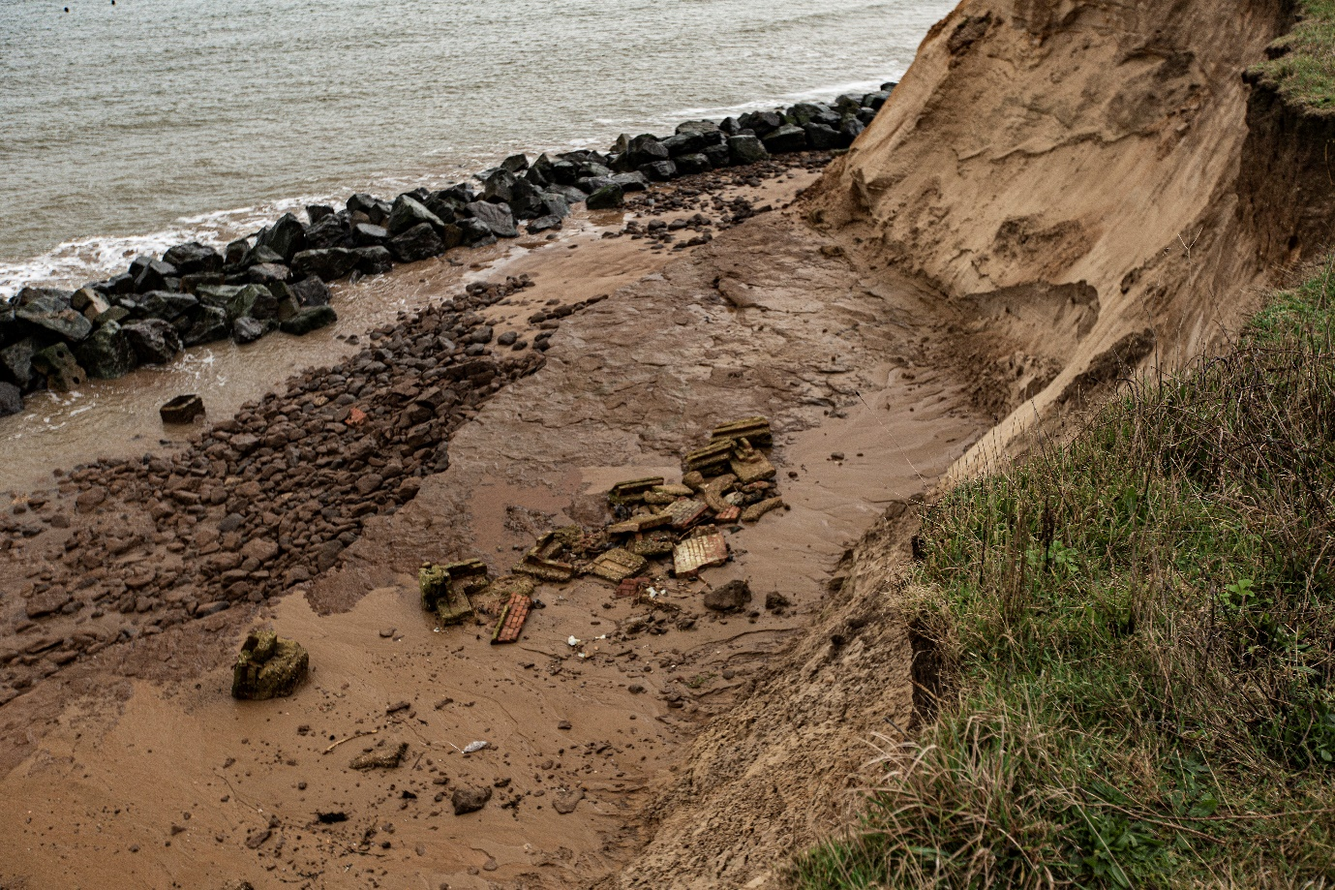
Fig 4 Alan D Horn Nov 2019 Rock Armour and further collapse of cliff and part of a garden.

812 words less quotes
215
597

